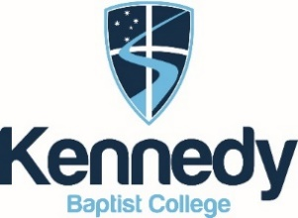ASSESSMENT OUTLINE- 2020 (Updated- 08/05)

CHEMISTRY ATAR Y11

UNITS 1 AND 2

|  |  |  |  |  |
| --- | --- | --- | --- | --- |
| Assessment type  (from syllabus) | Assessment  type weighting | Assessment  task  weighting | When | Assessment task |
| Practical and Investigation | **25%** | 9% | T3: Week 6 | **Task 9:** Post laboratory test 2 on**-** Reaction rate and concentration/ temperature, Intermolecular forces in alcohols |
| 8% | T1: Week 6 | **Task 3:** Determining the Waters of Crystallisation of an unknown salt. |
| 8% | T3: Week 7 | **Task 10:** Using chromatography to analyse the strength of intermolecular forces in various colours of ink. |
| Extended response | **10%** | 5% | T1: Week 3 | **Task 1:** Extended response 1 - Discovery of the atom. |
| 5% | T3: Week 1 | **Task 7:** Extended response 2- Energy and CO2 output for fossil fuels and biofuels |
| Test | **15%** | 2% | T1: Week 4 | **Task 2:** Properties and Structure of Atoms |
| 2.5% | T2: Week 4 | **Task 4:** Properties and Structure of Materials: Organic Chemistry |
| 3% | T2: Week 5 | **Task 5:** Chemical Reactions: Reactants, Products and Energy Change |
| 2% | T3: Week 2 | **Task 8:** Rates of Chemical Reactions |
| 2.5% | T3: Week 9 | **Task 11:** Intermolecular Forces and Gases |
| 3% | T4: Week 3 | **Task 12:** Aqueous Solutions and Acidity |
| Examination | **50%** | 15% | T2: Week 7-8 | **Task 6:** Semester 1 examination – Covers Unit 1 content |
| 35% | T4: Week 5-6 | **Task 13:** Semester 2 examination – Covers Unit 1 and 2 content |
| Total | **100%** | **100%** |  |  |